Practical no. 1:

Step no.1: Open folder in any name.
Step no.2: Open Command Prompt (cd).
Step no.3: Type command:
1: dir
2: cd downloads
3: mkdir ( Folder name)
4: npx create-react-app (Folder name)
And running this process :
Go to V.S code and open your folder.
Open App.js file
App.js code:
import logo from './logo.svg';
import './App.css';
function App() {
return (
<div className="App">
<header className="App-header">
<img src={logo} className="App-logo" alt="logo" />
<p>
Edit <code>src/App.js</code> and save to reload.
</p>
<a
className="App-link"
href="https://reactjs.org"
target="_blank"
rel="noopener noreferrer"
>
Learn React
</a>
</header>
</div>
);
}
export default App;

Run terminal
Type command: npm start
Open any Browser

Output:

Practical no. 2: JSX and component creation using props.

1. Create a file greeting.js write this code, in greeting.js
function Greeting(props){
return <p>Hello, {props.name}!
Nice to see you. </p>;
}
export default Greeting;

2. App.js
Write this code in App.js and App.js
import React from 'react';
import Greeting from './Greeting';
function App() {
return (
<div>
<h1>Welcome to the App</h1>
<Greeting name="Om"/>
<Greeting name="Parab"/>
<Greeting name="Rahul"/>
</div>
);
}
export default App;
3. Run this code npm start
Output:
Practical no. 3: State management in React using use state: Building counter app

Import React, { useState } from ‘react’;

Function CounterApp() {

Const [count, setCount] = useState(0);

Const increment = () => setCount(count + 1);
Const decrement = () => setCount(count – 1);
Const reset = () => setCount(0);

Return (
<div style={{ textAlign: ‘center’, marginTop: ‘50px’ }}>
<h1>Simple Counter App</h1>
<h2>Count: {count}</h2>
<button onClick={increment}>➕ Increment</button>{‘ ‘}
<button onClick={decrement}>➖ Decrement</button>{‘ ‘}
<button onClick={reset}> Reset</button>
</div>
);
}

export default CounterApp;
Output:
Practical no.4: Event Handling in React: Managing Button Clicks and Input Changes.

import React, { useState } from 'react';

function EventHandlingExample() {
const [name, setName] = useState('');
const [message, setMessage] = useState('');

const handleInputChange = (e) => {
setName(e.target.value);
};

const handleButtonClick = () => {
setMessage(`Hello, ${name}!`);
};

return (
<div>
<h2>Event Handling Example</h2>

<input
type="text"
placeholder="Enter your name"
value={name}
onChange={handleInputChange}/>

<button onClick={handleButtonClick}>Greet</button>
<p>{message}</p>
</div>
);
}

export default EventHandlingExample;

Output:

Practical no.5: Rendering Dynamic Lists in React Using Array Mapping and Key Props

import React from 'react';
const FruitsList = () => {
const fruits = ['Pineapple', 'Jackfruit', 'Watermelon'];
return (
<ul>
<h1>FRUITS LIST</h1>
{fruits.map((fruit, index) => (
<li key={index}>{fruit}</li>
))}
</ul>
);
};
export default FruitsList;

Output:

Practical no.6: Building Controlled Forms in React: Managing State and Implementing Basic Validation

import { useState } from 'react';
export default function MyForm() {

const [inputValue, setInputValue] = useState('');
const [inputError, setInputError] = useState(null);

function handleInputChange(event) {
const value = event.target.value;
setInputValue(value);

if (value.length < 5) {
setInputError('Input must be at least 5 characters');
} else {
setInputError(null);
}
}

function handleSubmit(event) {
event.preventDefault();

if (inputValue.length >= 5) {
} else {
setInputError('Input must be at least 5 characters');
}
}

return (
<form onSubmit={handleSubmit} style={{margin:"50px"}}>
<label>
Fruit:
<input type="text" value={inputValue} onChange={handleInputChange} />
</label>
{inputError && <div style={{ color: 'red' }}>{inputError}</div>}
<button type="submit">Submit</button>
</form>
);
}

Output:

Practical no.7: Styling React Components: Implementing CSS Modules and Inline Styles

import React from "react";
const pStyle = {
fontSize: "16px",
color: "blue"
};
export default function App() {
return (
<>
<p style={pStyle}>
The weather is sunny with a small chance of rain today.
</p>
<p style={{ ...pStyle, color: "green", textAlign: "right" }}>
More you travel, more you explore </p>
</>
);
}

Output:

Practical no.8: Conditional styling in React using both CSS Modules and inline styles. (Toggle Button with Conditional Styling).

toggle.css
.container {
padding: 30px;
text-align: center;
border: 2px solid #ccc;
width: 300px;
margin: 50px auto;
border-radius: 10px;
}

.label {
font-size: 24px;
margin-bottom: 20px;
display: block;
}

App.js
import React, { useState } from 'react';
import styles from './toggle.css';

const ToggleButton = () => {
const [isOn, setIsOn] = useState(false);

const buttonStyle = {
backgroundColor: isOn ? '#4CAF50' : '#f44336',
color: 'white',
padding: '12px 20px',
border: 'none',
borderRadius: '5px',
fontSize: '16px',
cursor: 'pointer',
transition: 'background-color 0.3s ease',
};

return (
<div className={styles.container}>
<span className={styles.label}>Toggle is {isOn ? 'ON' : 'OFF'}</span>
<button style={buttonStyle} onClick={() => setIsOn(!isOn)}>
{isOn ? 'Turn OFF' : 'Turn ON'}
</button>
</div>
);
};

export default ToggleButton;

Output:

Practical no:9 Developing a Personal Portfolio Website with React and Bootstrap.

App.js
import React from 'react'; import Navbar from './components/Navbar'; import Home from './components/Home'; import About from './components/About'; import Projects from './components/Projects'; import Footer from './components/Footer'; function App() { return (
<div>
<Navbar />
<Home />
<About />
<Projects />
<Footer />
</div>
); }
export default App;

Nvabar.js
import React from 'react'; function Navbar() {
return (
<nav className="navbar navbar-expand-lg navbar-dark bg-dark">
<div className="container">
<a className="navbar-brand">My Portfolio</a>
<div className="collapse navbar-collapse">
<ul className="navbar-nav ms-auto">
<li className="nav-item"><a className="nav-link" href="#home">Home</a></li>
<li className="nav-item"><a className="nav-link" href="#about">About</a></li>
<li className="nav-item"><a className="nav-link" href="#projects">Projects</a></li> </ul>
</div>
</div>
</nav>
); }
export default Navbar;
Home.js
import React from 'react';
function Home() { return (
<section id="home" className="bg-dark text-center py-6">
<div className="container"> <h1>Hello, I’m Kumkum</h1>
<p>Frontend Developer | React Enthusiast</p>
</div>
</section>
); }
export default Home;

About.js
import React from 'react'; function About() {
return (
<section id="about" className="py-5">
<div className="container">
<h2>About Me</h2>
<p>I am a passionate web developer with skills in React, Bootstrap, and modern web technologies.</p>
</div>
</section>
); }
export default About;

Projects.js import React from 'react'; function Projects() {
return (
<section id="projects" className="bg-light py-5">
<div className="container">
<h2>Projects</h2>
<ul>
<li>Portfolio Website</li>
<li>To-do App with React</li>
<li>Weather App using API</li>
</ul>
</div>
</section>
); }
export default Projects;

Footer.js
import React from 'react'; function Footer() {
return (
<footer className="bg-dark text-white text-center py-3">
<p>&copy; 2025 My Portfolio. All rights reserved.</p>
</footer>
); }
export default Footer; Index.js
import React from 'react'; import ReactDOM from 'react-dom/client';
import './index.css'; import App from './App';
import reportWebVitals from './reportWebVitals';

const root = ReactDOM.createRoot(document.getElementById('root')); root.render( <React.StrictMode>
<App />
</React.StrictMode>
);

Output:-
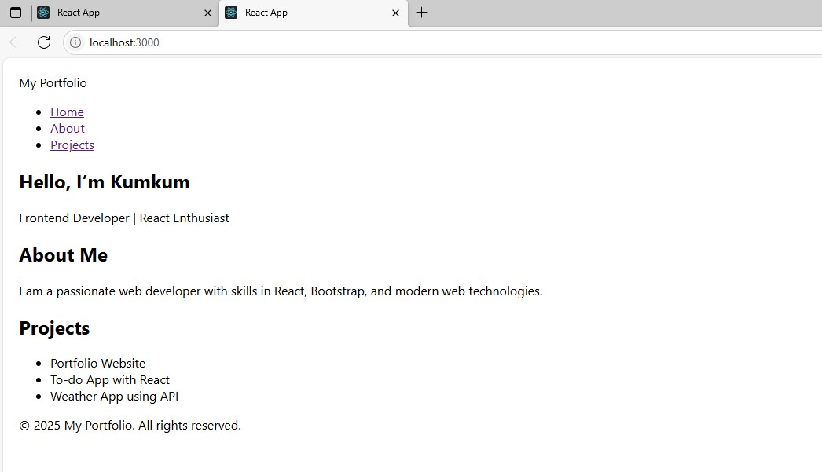

Name: Parab Ravindra Swami Roll no: 124 Div : B
Class: SYBCA Batch: B6
Practical No:10 Setting Up a Node.js and Express.js Development Environment: A Practical Guide.

const express = require('express'); const cors = require('cors'); const app = express(); const PORT = 5000; app.use(cors()); app.use(express.json()); // Dummy API
app.get('/api/message', (req, res) => {
res.json({ message: "welcome to our institude" });
});
app.listen(PORT, () => {
console.log(`Server running on http://localhost:${PORT}`); });
Output:
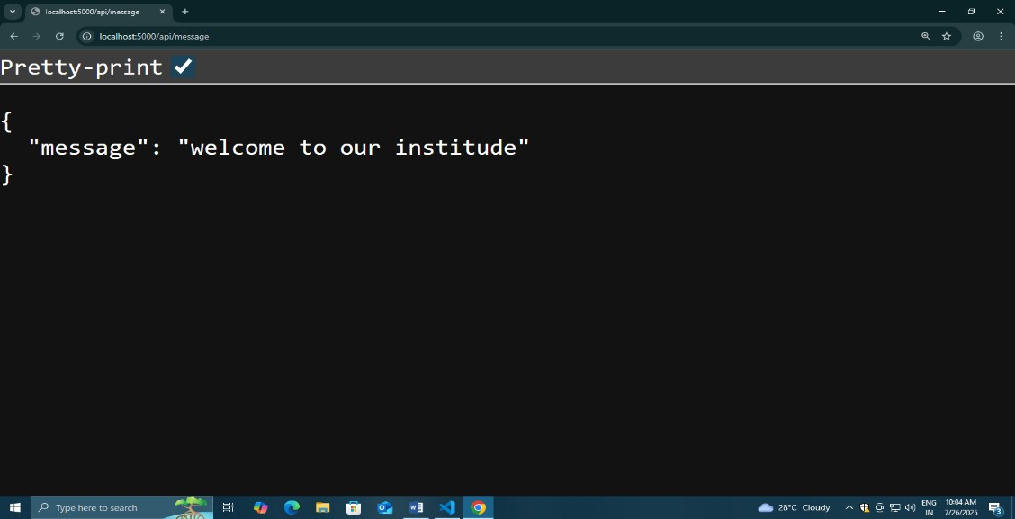

Name:Om Ramakant Parvate Roll no.: 68 Course: SYBCA
Practical no.11: Implementing Basic Routing in Express.js: Creating Multiple GET Endpoints.

Step: 1:- Create folder on desktop.Then open folder and open cmd in that folder.
Step: 2:- npm init –y
Step: 3:- npm install express then code . Step: 4:- Create Index.js in vs code and type this code.

const express = require('express'); const app = express();
const port = 3000;

app.get('/', (req, res) => {
res.send('Welcome to the My Program!');
});

app.get('/about', (req, res) => { res.send('This is the About Web Page.');
});

app.get('/contact', (req, res) => { res.send('Contact us at aiabi45@gmail.com');
});

app.get('/services', (req, res) => {
res.send('Here are our services: Web Development, App Development, SEO.');
});

app.listen(port, () => {
console.log(`Server running at http://localhost:${port}`);
});
Step 5: Run this in terminal node index.js

Output:
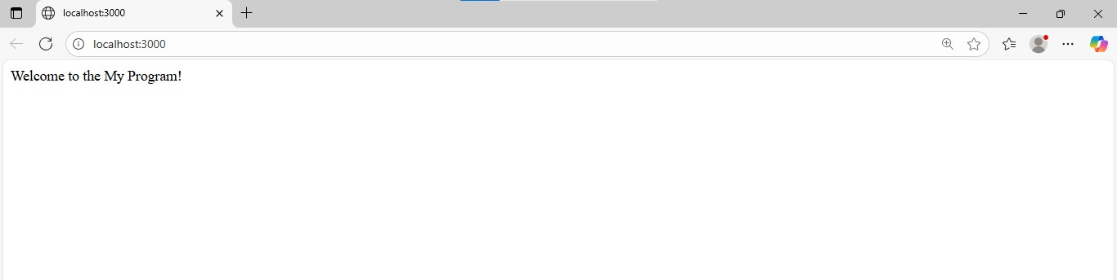

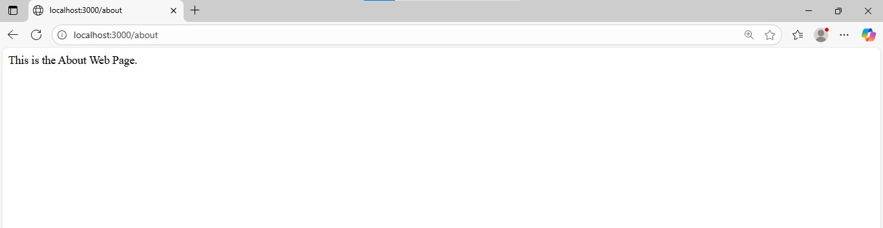

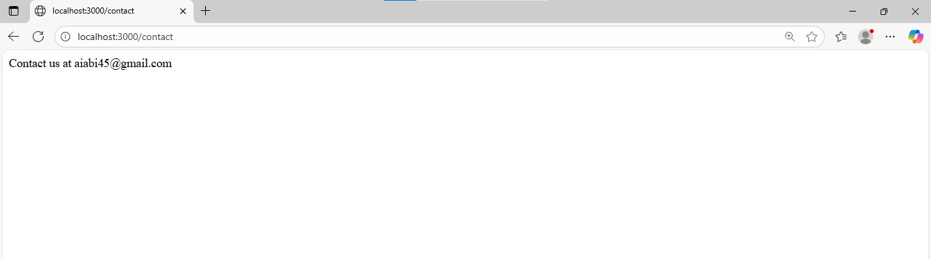

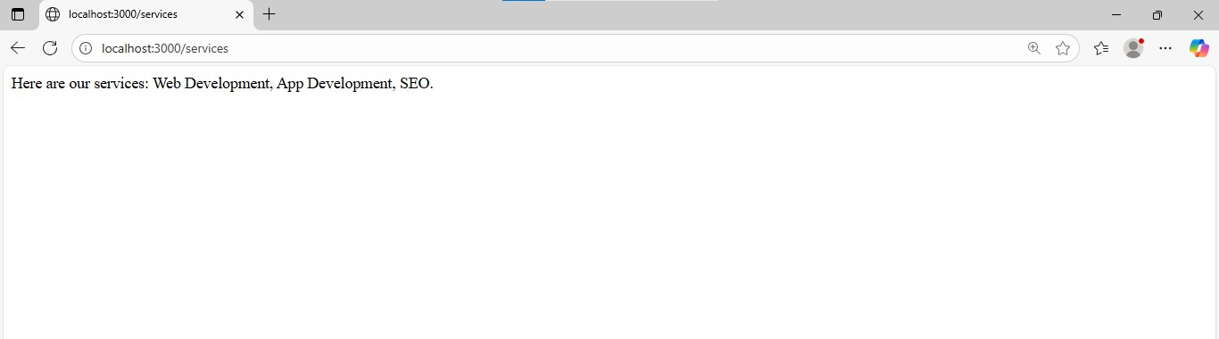

Name: Om Ramakant Parvate Roll no: 68 Div : B
Class: SYBCA Batch: B6
Practical no.12- Building a RESTful API with Express.js: A Hands-On Guide to HTTP Methods on (Customer details)

const express = require('express'); const app = express(); const port = 3000;
app.use(express.json());

let customers = [
{ id: 1, name: 'OM', email: 'Om@example.com' },
{ id: 2, name: 'Lalit', email: 'lalit424@example.com' }
];

app.get('/customers', (req, res) => { res.json(customers);
});

app.get('/customers/:id', (req, res) => { const id = parseInt(req.params.id); const customer = customers.find(c => c.id === id); if (!customer) { return res.status(404).send('Customer not found');
}
res.json(customer);
});

app.post('/customers', (req, res) => { const { name, email } = req.body; const newCustomer = { id: customers.length + 1, name, email
};
customers.push(newCustomer);
res.status(201).json(newCustomer);
});

app.put('/customers/:id', (req, res) => { const id = parseInt(req.params.id); const customer = customers.find(c => c.id === id); if (!customer) { return res.status(404).send('Customer not found');
} customer.name = req.body.name || customer.name;
customer.email = req.body.email || customer.email;

res.json(customer);
});

app.delete('/customers/:id', (req, res) => { const id = parseInt(req.params.id); const index = customers.findIndex(c => c.id === id); if (index === -1) { return res.status(404).send('Customer not found');
}
const deletedCustomer = customers.splice(index, 1); res.json(deletedCustomer);
});

app.listen(port, () => { console.log(`Customer API is running at http://localhost:${port}`);
});

- GET all customers
URL: http://localhost:3000/customers
Method: GET
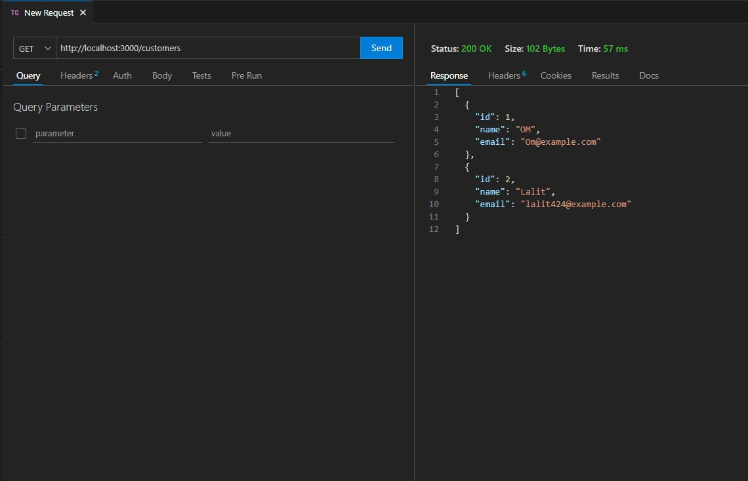

- GET a customer by ID
URL: http://localhost:3000/customers/1
Method: GET
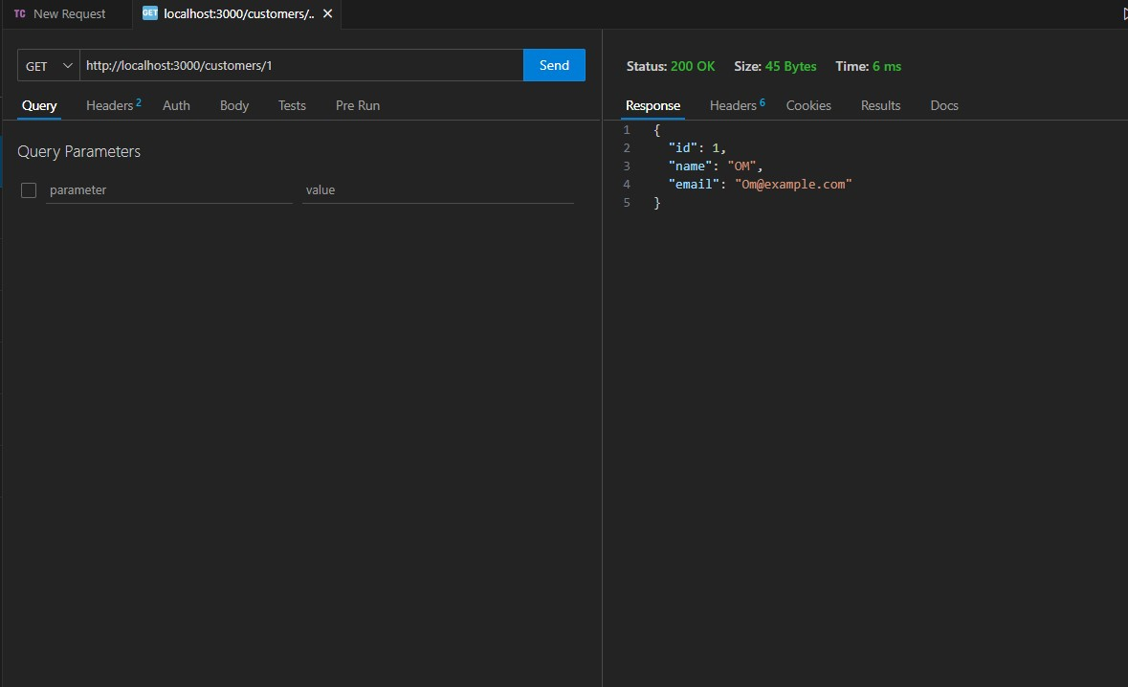

- POST a new customer
URL: http://localhost:3000/customers
Method: POST
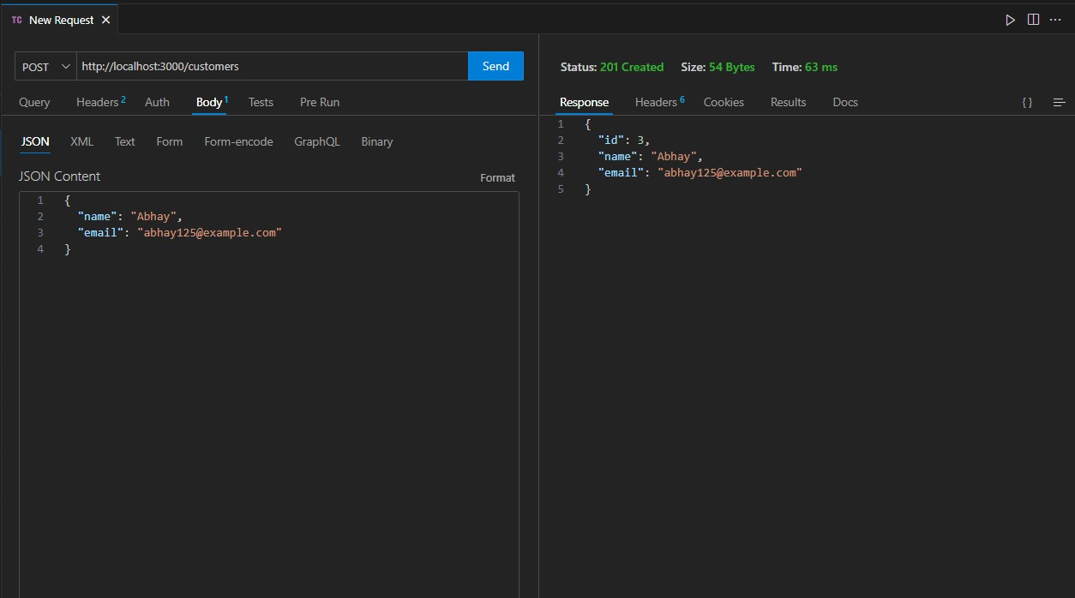
4.PUT (update) a customer
URL: http://localhost:3000/customers/2
Method: PUT
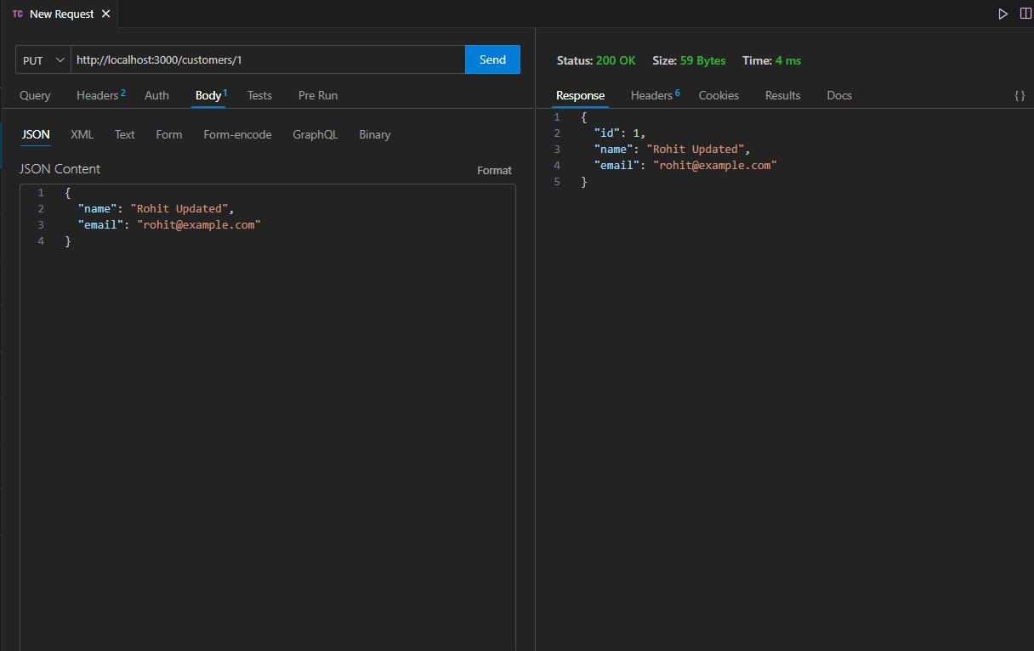
5. DELETE a customer
URL: http://localhost:3000/customers/1
Method: DELETE
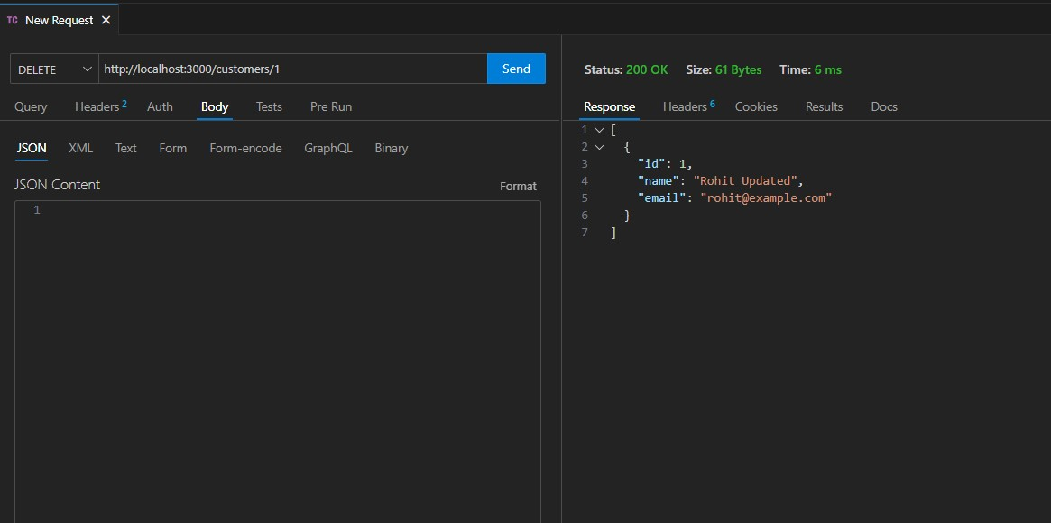

Name: Parab Ravindra Swami Roll no: 124 Div : B
Class: SYBCA Batch: B6
Practical 13 :- Building RESTful APIs: Managing JSON POST Requests in Express.js (Employee Post Method).

1. Create a new folder for your project and open it in terminal. 2. Run: npm init –y npm install express

Code:-
const express = require('express'); const app = express(); const port = 3000; app.use(express.json()); let employees = [
{ id: 1, name: 'Alice', role: 'Developer' },
{ id: 2, name: 'Bob', role: 'Designer' }
];
app.get('/employees', (req, res) => { res.json(employees);
});
app.post('/employees', (req, res) => { const newEmployee = req.body;
if (!newEmployee.name || !newEmployee.role) {
return res.status(400).json({ error: 'Name and role are required' });
}
newEmployee.id = employees.length + 1; employees.push(newEmployee); res.status(201).json(newEmployee);
});
app.listen(port, () => {
console.log(`Server running at http://localhost:${port}`);
});
Output:-
Run your server
Run in terminal: node index.js
You should see: Server running at http://localhost:3000 Open your browser or Postman and visit:
http://localhost:3000/employees
GET:

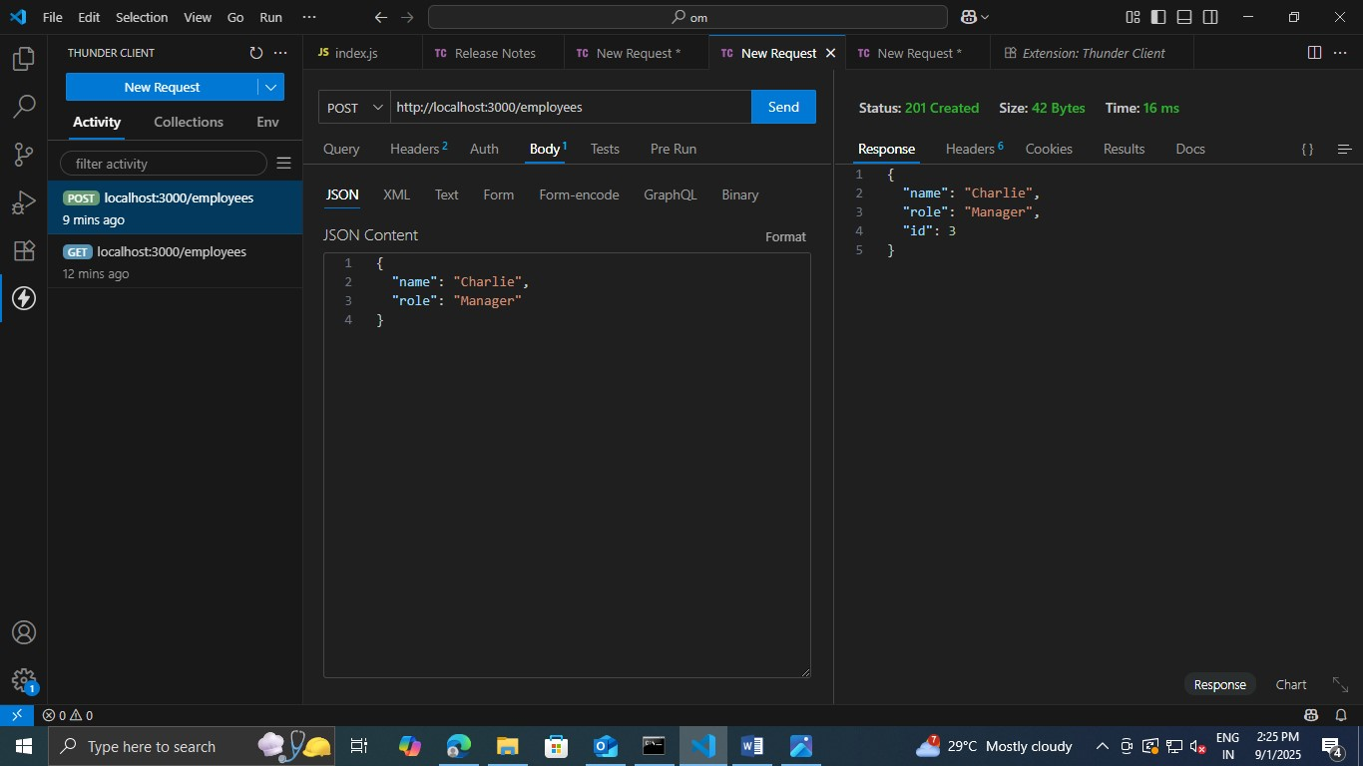
POST:-
Use Postman or curl to send a POST request to: http://localhost:3000/employees
With this JSON body:
{
"name": "Charlie",
"role": "Manager"
}

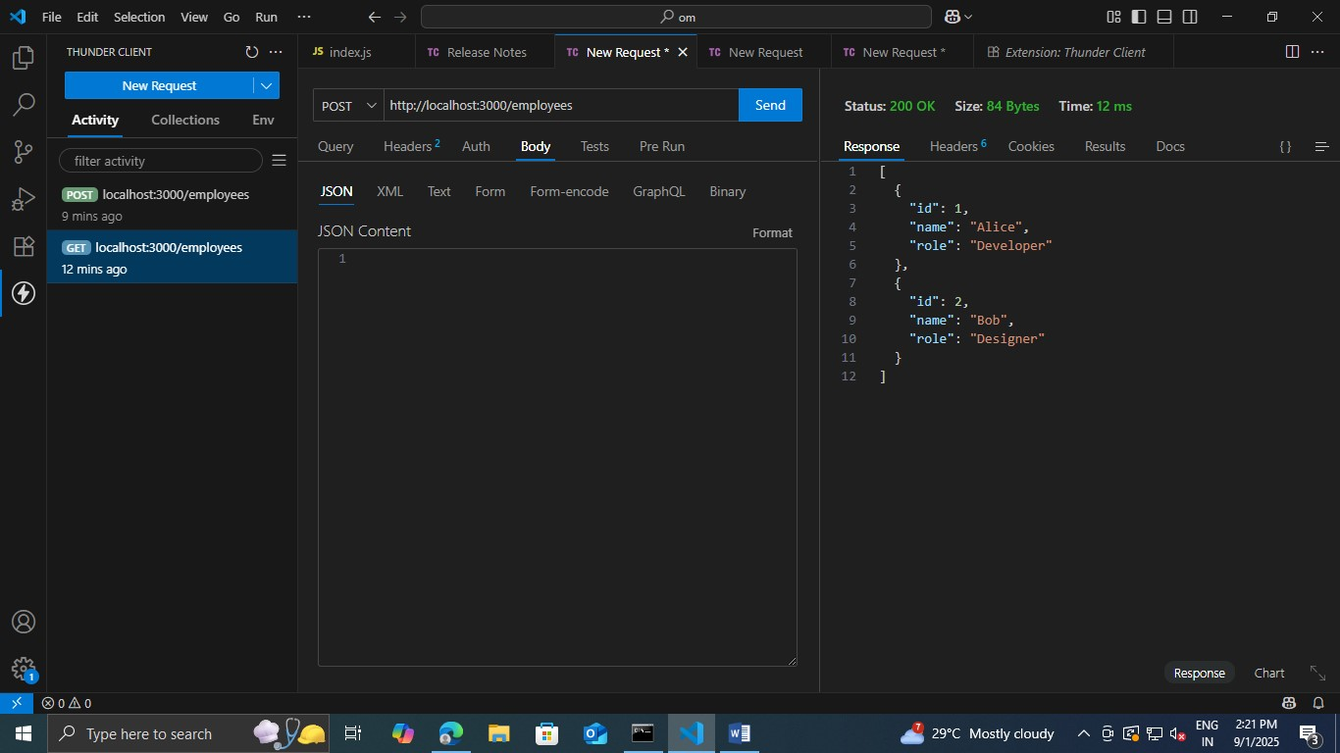

Name: Parab Ravindra Swami Roll no.: 124 Course: SYBCA
Practical no.14: Implementing CRUD Operations (Students)Using RE/STful API and HTTP Methods.

const express = require('express'); const app = express(); const port = 3000; app.use(express.json());

let students = []; let nextId = 1;
// CREATE - Add new student app.post('/students', (req, res) => { const student = { id: nextId++, ...req.body }; students.push(student);
res.status(201).json({ message: 'Student created', student }); });

app.get('/students', (req, res) => { res.json(students);
});
app.get('/students/:id', (req, res) => {
const student = students.find(s => s.id == req.params.id); if (!student) {
return res.status(404).json({ message: 'Student not found' });
}
res.json(student);
});

app.put('/students/:id', (req, res) => {
const index = students.findIndex(s => s.id == req.params.id); if (index === -1) {
return res.status(404).json({ message: 'Student not found' });
}
students[index] = { id: students[index].id, ...req.body }; res.json({ message: 'Student updated', student: students[index] });
});

app.delete('/students/:id', (req, res) => {
const index = students.findIndex(s => s.id == req.params.id); if (index === -1) {
return res.status(404).json({ message: 'Student not found' });
}
const removedStudent = students.splice(index, 1);
res.json({ message: 'Student deleted', student: removedStudent[0] });
});

app.listen(port, () => {
console.log(`Server running at http://localhost:${port}`);
});

Output:
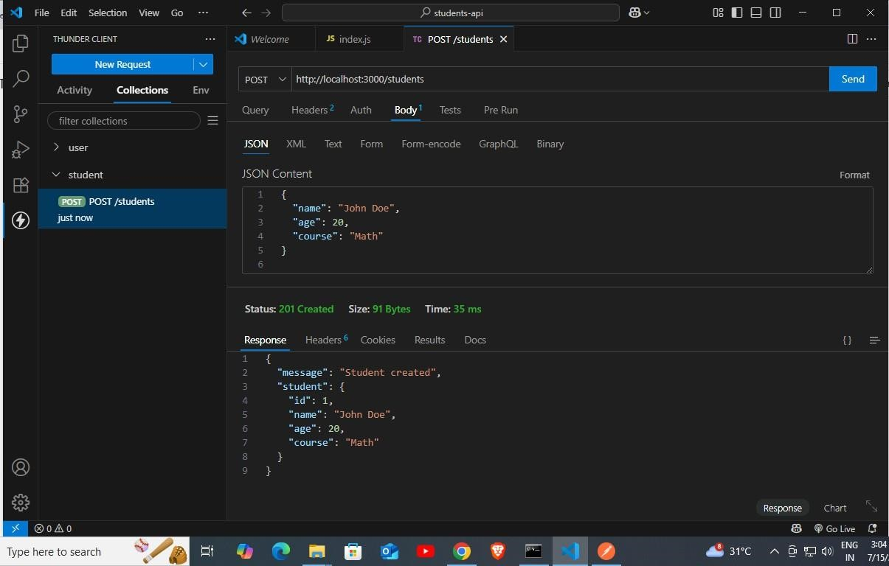

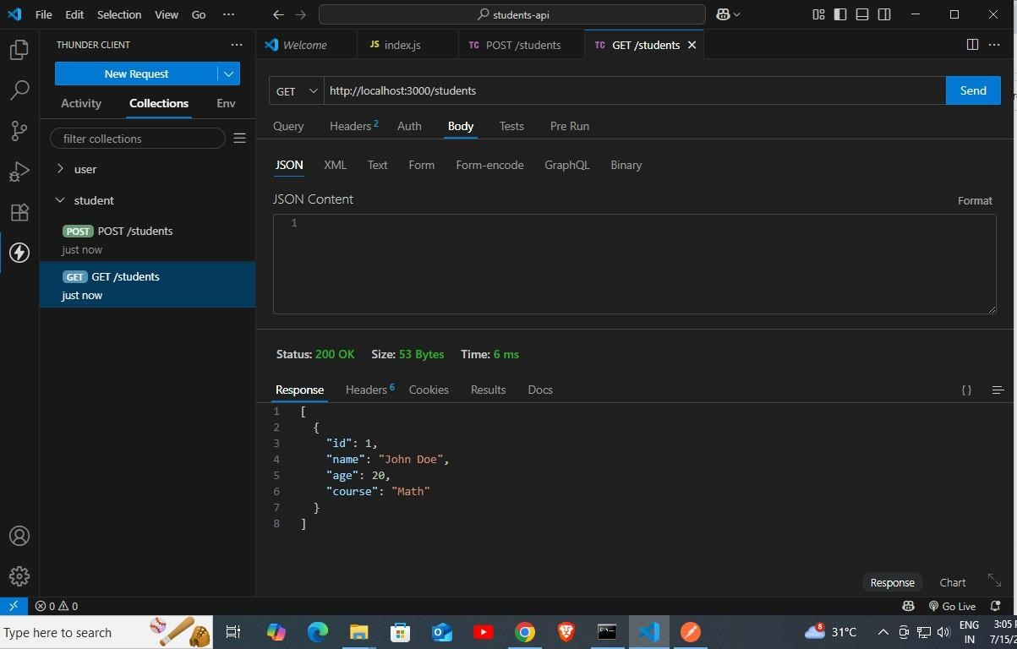
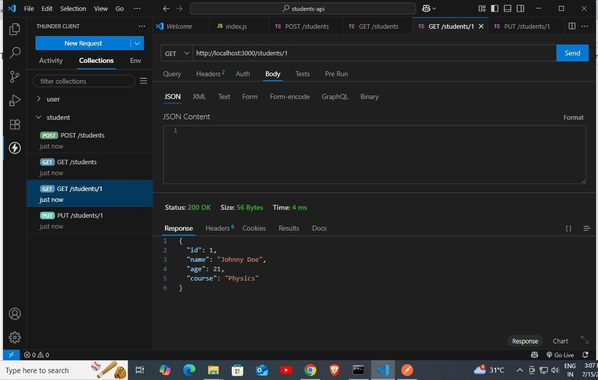

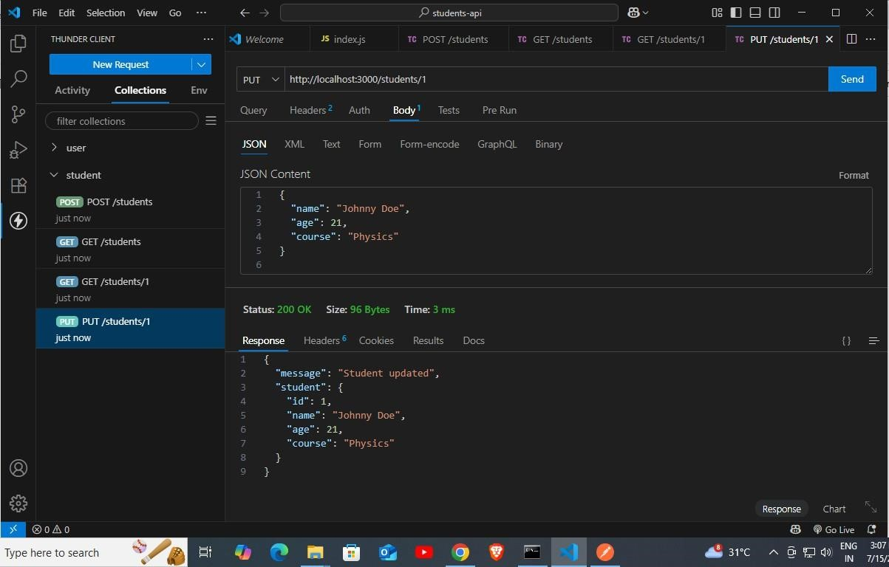

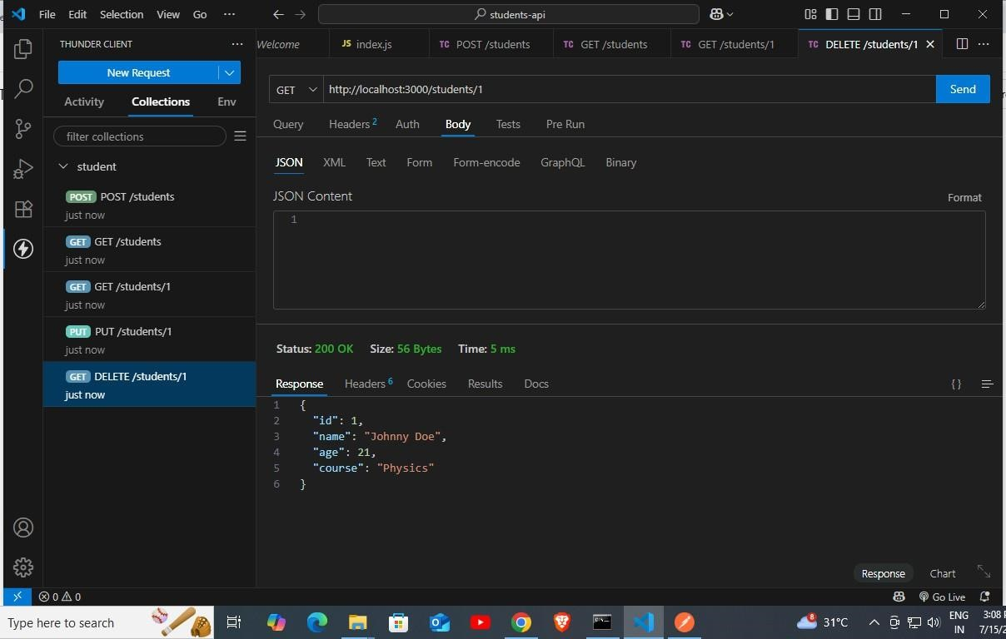

PRACTICAL 15: SETTING UP MONGO DB ENVIRONMENT: TEACHERS API WITH MONGODB BY USING MONGODB COMPASS.

Server.js:

const express = require('express'); const mongoose = require('mongoose'); const app = express();
app.use(express.json()); // middleware to parse JSON

// Connect to MongoDB mongoose.connect("mongodb://127.0.0.1:27017/MongoDB", { useNewUrlParser: true,
useUnifiedTopology: true,
})
.then(() => console.log("Connected to MongoDB"))
.catch(err => console.error(" MongoDB connection error:", err));

// Create Teacher Schema
const teacherSchema = new mongoose.Schema({ name: String,
subject: String, email: String, experience: Number, available: Boolean
});

// Create Teacher Model
const Teacher = mongoose.model('Teacher', teacherSchema);
// Get all teachers
app.get('/teachers', async (req, res) => { const teachers = await Teacher.find(); res.json(teachers);
});

// Add new teacher
app.post('/teachers', async (req, res) => { const teacher = new Teacher(req.body); await teacher.save(); res.status(201).json(teacher);
});

// Get teacher by ID
app.get('/teachers/:id', async (req, res) => {
const teacher = await Teacher.findById(req.params.id);

if (!teacher) return res.status(404).send('Teacher not found'); res.json(teacher);
});

// Update teacher by ID app.put('/teachers/:id', async (req, res) => {
const teacher = await Teacher.findByIdAndUpdate(req.params.id, req.body, { new: true }); if (!teacher) return res.status(404).send('Teacher not found');
res.json(teacher);
});

// Delete teacher by ID app.delete('/teachers/:id', async (req, res) => {
const result = await Teacher.findByIdAndDelete(req.params.id); if (!result) return res.status(404).send('Teacher not found'); res.send('Teacher deleted');
});

// Start the server const PORT = 3001;
app.listen(PORT, () => {
console.log(`Server is running at http://localhost:${PORT}`);
});

Output: POST

PUT

DELETE

Name: Parab Ravindra Swami Roll no.: 124 Div: B
Batch: B6 Class: SYBCA
Practical no.16: Setting up Mongo DB Environment: Teachers API with MongoDB by using MongoDB

Step 1: Backend Setup
open folder and write this commnds in cmd mkdir inventory-mini-api cd inventory-mini-api npm init -y
npm install express mongoose cors Create server.js
const express = require('express'); const mongoose = require('mongoose'); const cors = require('cors'); const app = express(); app.use(cors()); app.use(express.json());
mongoose.connect('mongodb://127.0.0.1:27017/inventoryDB', { useNewUrlParser: true, useUnifiedTopology: true
});
mongoose.connection.once("open", () => { console.log("✅ Connected to MongoDB");
});
mongoose.connection.on("error", (err) => { console.error("❌ MongoDB connection error:", err);
});
const Item = mongoose.model('Item', new mongoose.Schema({ name: String, quantity: Number
}));
app.get('/items', async (req, res) => { try {
const items = await Item.find(); res.json(items); } catch (err) {
console.error("Error fetching items:", err); res.status(500).json({ error: "Failed to fetch items" });
} });
app.post('/items', async (req, res) => { try {
const { name, quantity } = req.body; if (!name || !quantity) {
return res.status(400).json({ error: "Name and Quantity required" });
}
const item = new Item({ name, quantity }); await item.save(); res.json(item); } catch (err) {
console.error("Error saving item:", err); res.status(500).json({ error: "Failed to save item" });
} });
app.delete('/items/:id', async (req, res) => {
try {
await Item.findByIdAndDelete(req.params.id); res.json({ message: "Item deleted" });
} catch (err) {
console.error("Error deleting item:", err); res.status(500).json({ error: "Failed to delete item" });
} });
app.listen(5000, () => console.log('🚀 Backend running on http://localhost:5000'));
💻 Frontend: React
Step 2: Frontend Setup
Open new terminal in VS Code and run this commands Create React App
npx create-react-app inventory-mini-client cd inventory-mini-client npm install axios
/App.js will be created :
// src/App.js import React, { useEffect, useState } from 'react'; import axios from 'axios';
const API = "http://localhost:5000/items"; function App() {
const [items, setItems] = useState([]); const [name, setName] = useState(''); const [quantity, setQuantity] = useState(1);
const loadItems = async () => setItems((await axios.get(API)).data); const addItem = async () => { await axios.post(API, { name, quantity });
setName(''); setQuantity(1); loadItems();
};
const deleteItem = async (id) => { await axios.delete(`${API}/${id}`); loadItems();
};
useEffect(() => { loadItems(); }, []); return (
<div style={{ padding: 20 }}>
<h2>📦 Inventory</h2>
<input value={name} onChange={e => setName(e.target.value)} placeholder="Item Name" />
<input type="number" value={quantity} onChange={e => setQuantity(Number(e.target.value))} />
<button onClick={addItem}>Add</button>
<ul>
{items.map(item => (
<li key={item._id}>
{item.name} - Qty: {item.quantity}
<button onClick={() => deleteItem(item._id)}>❌</button>
</li>
))}
</ul>
</div>
);
}
export default App;
Run the App Backend:
cd inventory-mini-api node server.js Frontend:
cd inventory-mini-client npm start

Output:
